Basic Canine NeuroAnatomy and MRI Imaging Planes
By Karen Kennedy, RTMR, MappSc
The London Health Sciences Centre
London, Ontario, Canada
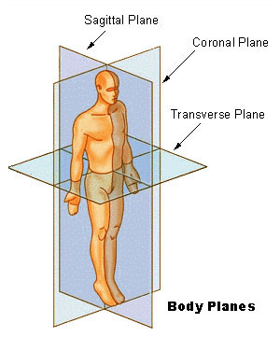

Sagittal - slice (blue line) thru the length of the body dividing it into left and right sides.
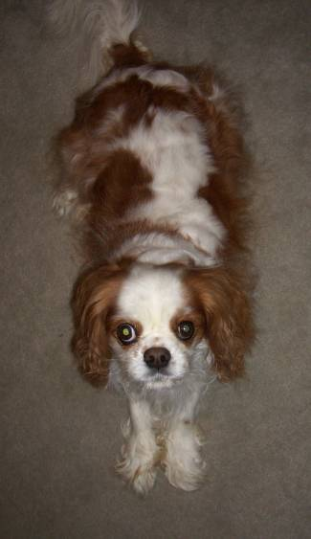
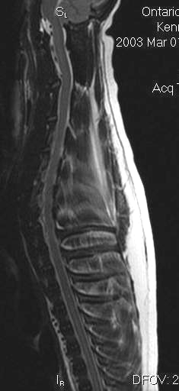

Sagittal of the spine

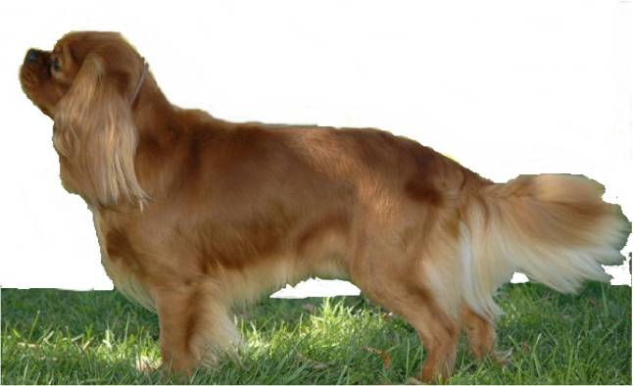

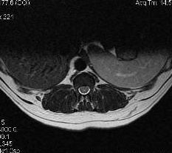
Transverse (axial or cross-section) – slice (blue line) cuts across the body
Transverse spine

Canine Spine

The cervical spine is located in the neck.
The thoracic spine is located in the chest. Ribs attach to the thoracic vertebrae.
The lumbar spine is the lower back area.
The sacral spine is in the tail.
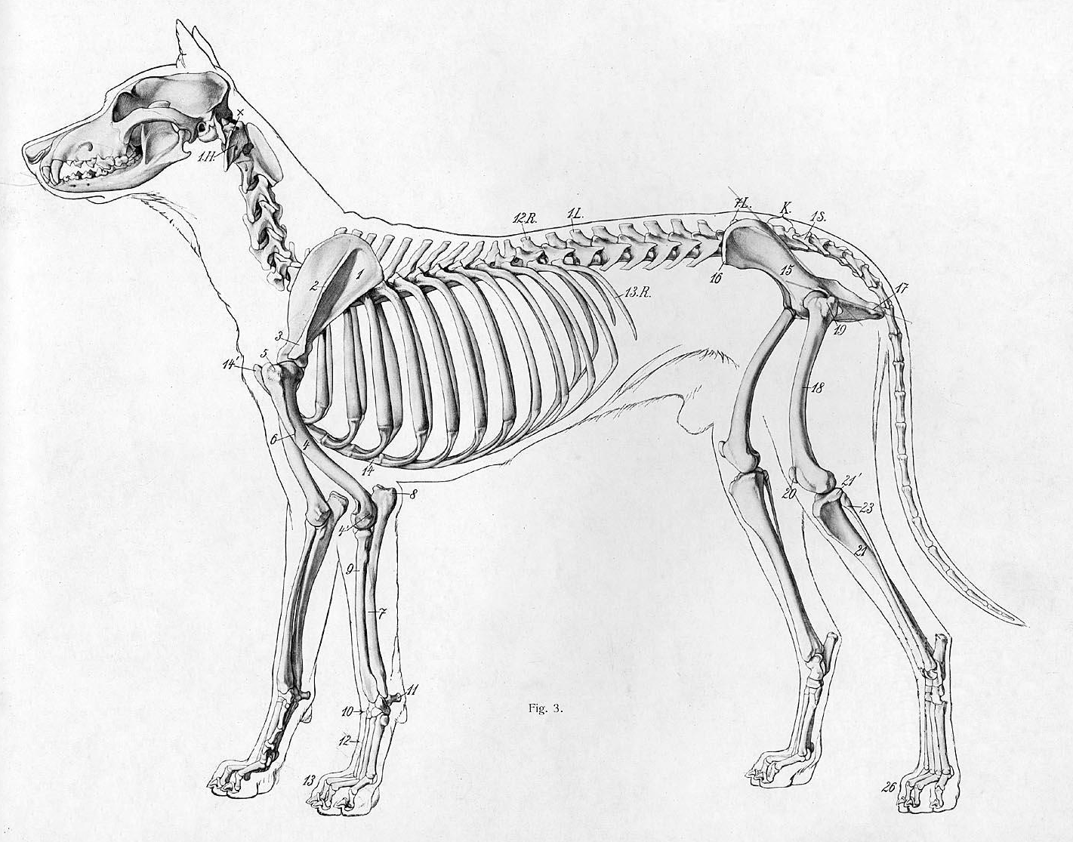
Cervical Spine
Thoracic Spine
Lumbar
Spine
Sacral
Spine
MRI Basics

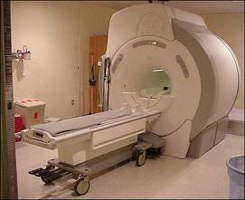
Magnetic Resonance Imaging (MRI) does not use radiation, and there are no known side effects. A very strong magnet is used to align the hydrogen protons in the body. By applying a radio frequency (RF)pulse, the protons can be flipped into a different plane. As they realign back to the original plane, they give off a signal that is read by the MR computer, and reconstructed into an image. Depending on the timing of the RF pulses different types of signals are generated that create different types of images. The most common are T1 and T2.

T1 and T2
T1 images typically provide better imaging of anatomy and bone. CSF is dark on a T1 image.
T2 images typically provide better imaging of fluid and pathologies (although bone is visible). CSF is white on a T2 image.
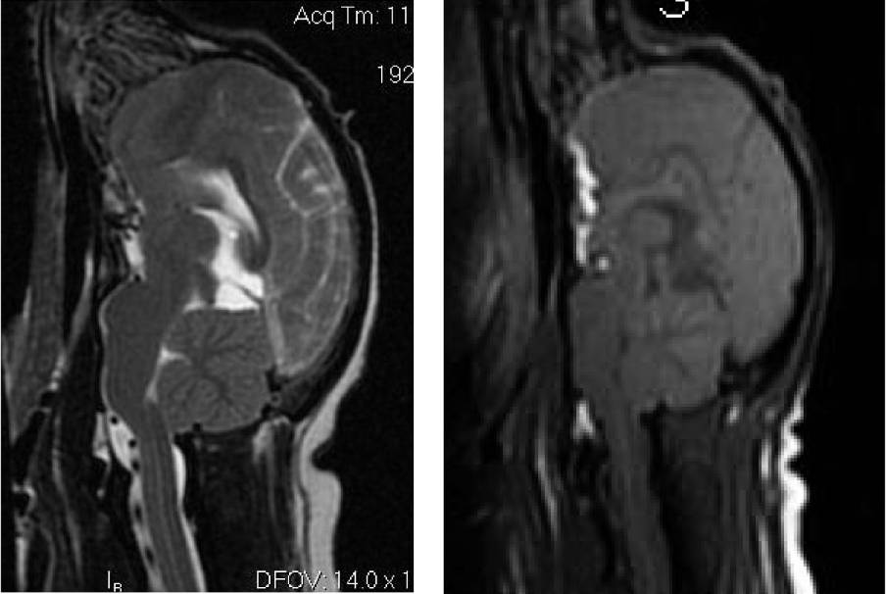
On Left: On Right:
T2 image T1 image
White CSF Dark CSF

T2 shows CSF better than a T1, therefore it shows a syrinx better. The T2 will also show hydrocephalus and if the 4th ventricle is compressed (the 4th ventricle should be a little triangle in front of the cerebellum and the brainstem).

MRI Normal Anatomy
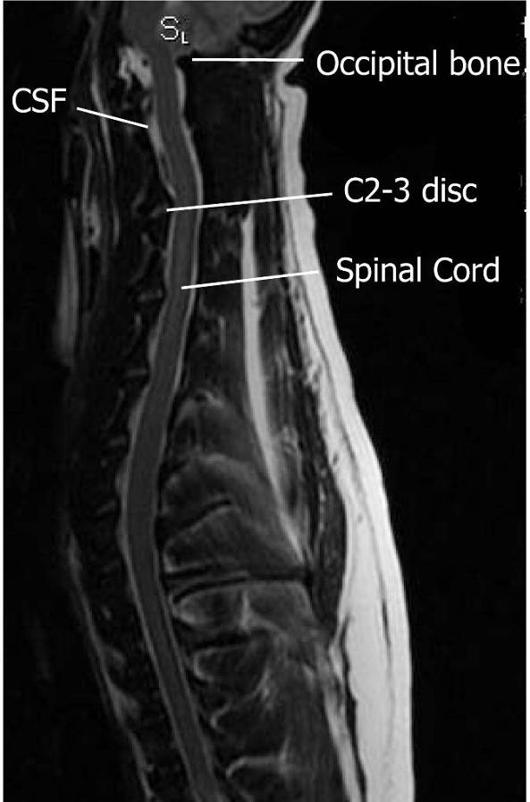
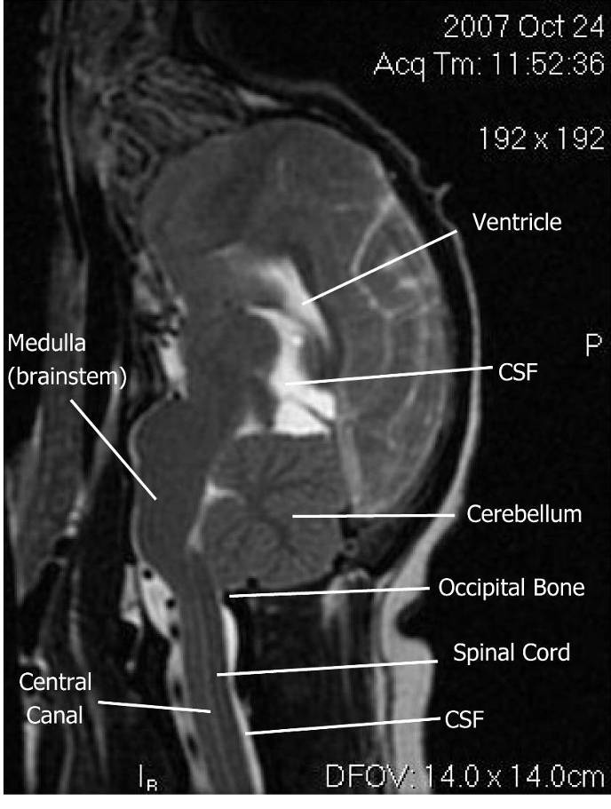
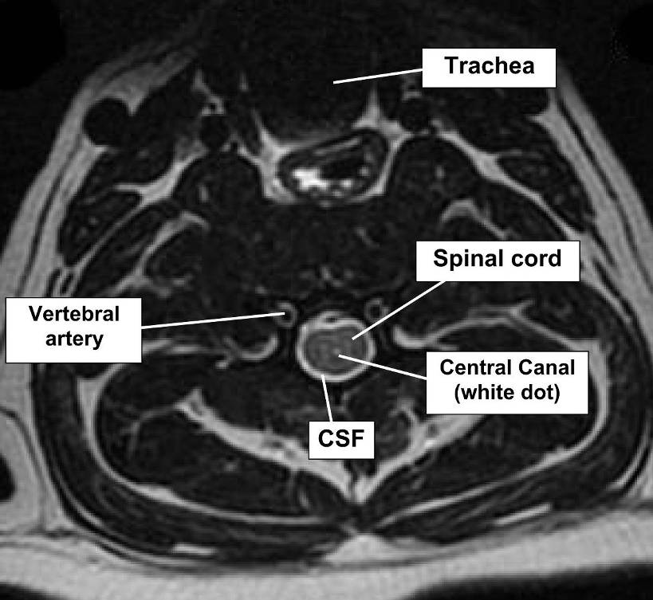
Sagittal T2
Brain and upper Cervical spine
Dorsal
(back)
4th
Ventricle
Sagittal T2
Cervical and Thoracic spine

Ventral
(throat)
Transverse
T2 Spine
(mid 3rd Cervical Vertebrae)
Ventral
(throat)
Dorsal
(back)
Glossary of Anatomical Directions
Term | Equivalent Term | Meaning | Short Form
Dorsal | Posterior | Toward the back
Ventral | Anterior | Toward the front (belly, abdomen, throat)
Cranial | Cephalad | Toward the head
Caudal |  | Toward the tail
Rostral |  | Toward the nose
Lateral |  | Toward the side
Medial |  | Toward the midline
Transverse | Axial | Cross section | Tran
Sagittal |  |  | Sag
Cervical spine |  | Vertebrae in neck | C spine
Thoracic spine |  | Vertebrae in chest/ mid back | T spine
Lumbar spine |  | Vertebrae in lower back | L spine
Cervical + Thoracic spine |  |  | CT spine
Thoracic + Lumbar spine |  |  | TL spine
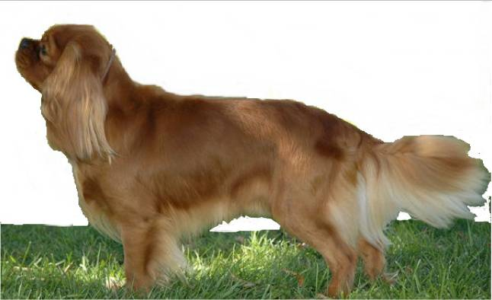
cranial
caudal
dorsal
ventral

