Understanding Canine Chiari Malformation and Syringomyelia
By Karen Kennedy, RTMR, MappSc
The London Health Sciences Centre
London, Ontario, Canada

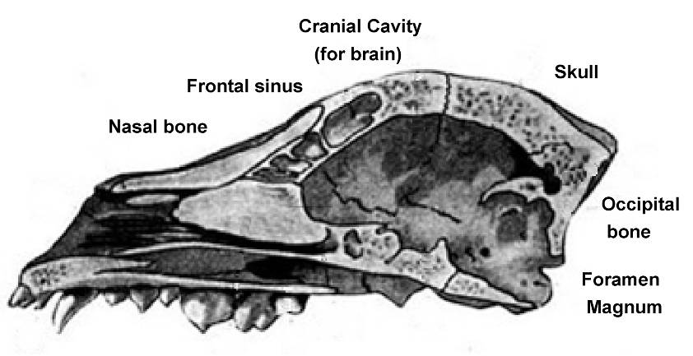
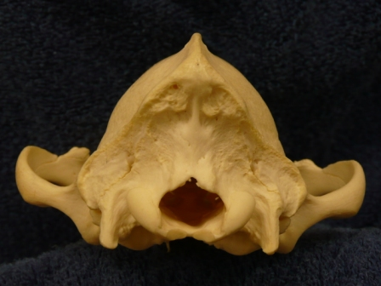
A Chiari Malformation (CM) occurs at the craniocervical junction. This is where the skull and the top of the spine meet. At the bottom of the skull, there is a large hole called the foramen magnum. The foramen magnum allows the brainstem to exit the skull and become the spinal cord.
Occipital
bone
top of head
Photograph of the back a canine skull
Foramen Magnum

Inside of skull from the side
When the lower lobe of the brain, the cerebellum, is displaced to the level of the foramen magnum (mild CM) or through the foramen magnum (severe CM) there is overcrowding in the foramen magnum. This causes obstruction of the normal flow of CSF from the brain down to the spinal cord. Many dogs with CM develop syringomyelia (SM). Syringomyelia is a condition where cavities, or holes, called a syrinx, develop within the spinal cord.
Normal
Chiari Malformation
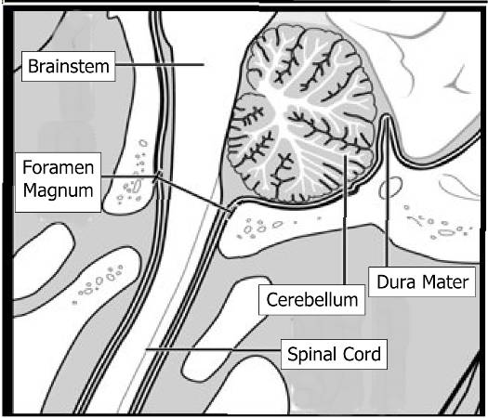
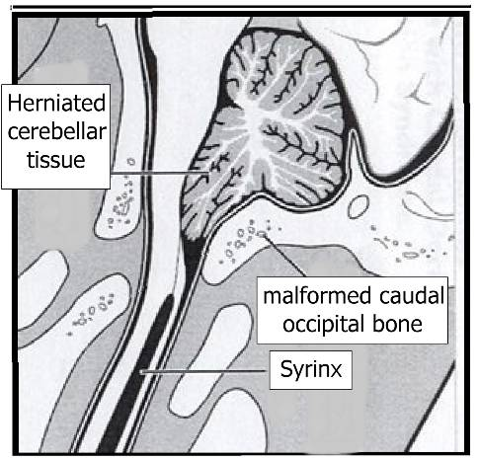

Diagrams courtesy of Dr. Dominic Marino. For further information on cranioplasty surgery, visit: www.livs.org
Craniocervical Junction - Cerebellum and Skull Base

Mixed Breed Cavalier Cavalier
Normal Mild Chiari Severe Chiari
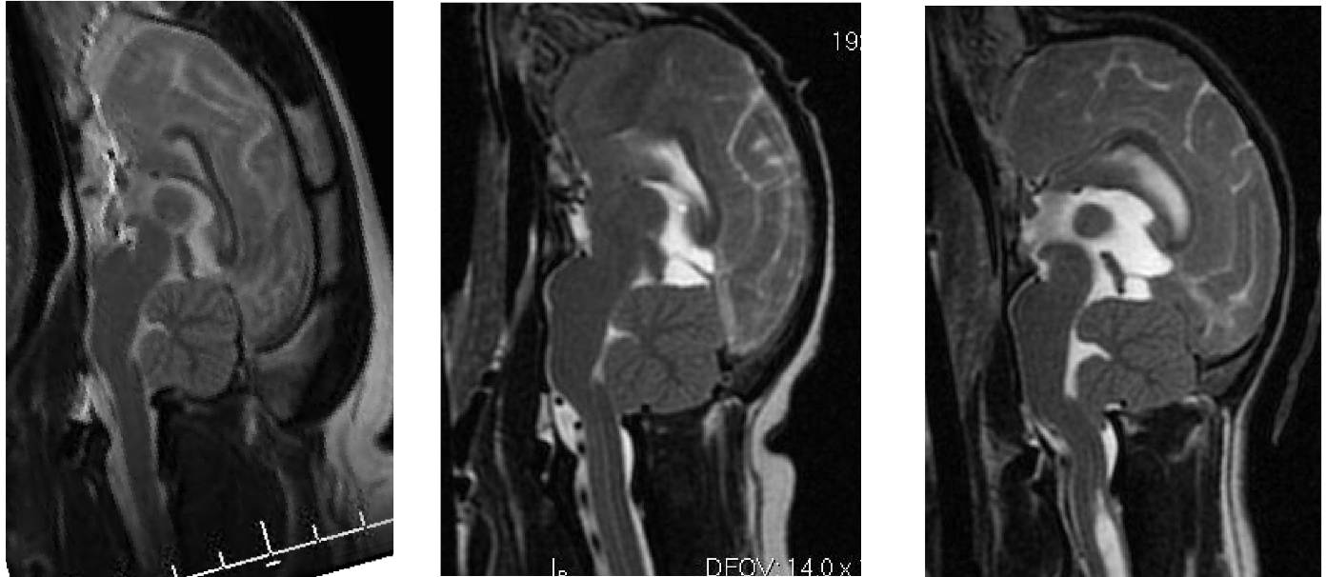

Red line = Foramen Magnum
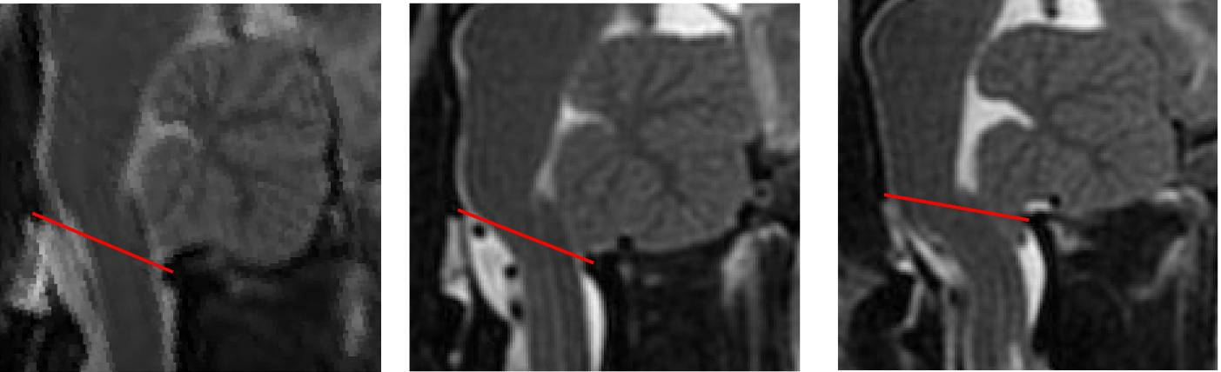
Cerebellum above foramen magnum with CSF (white) visible above foramen magnum
Cerebellum forced below foramen magnum
Cerebellum pushed to level of foramen magnum

MR images courtesy of Dr. K. Wolfe
Syringomyelia (Syrinx) images

Sagittal
Sagittal
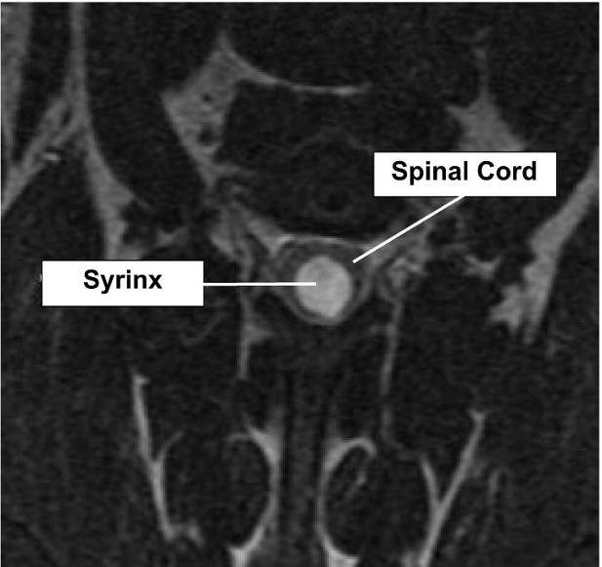
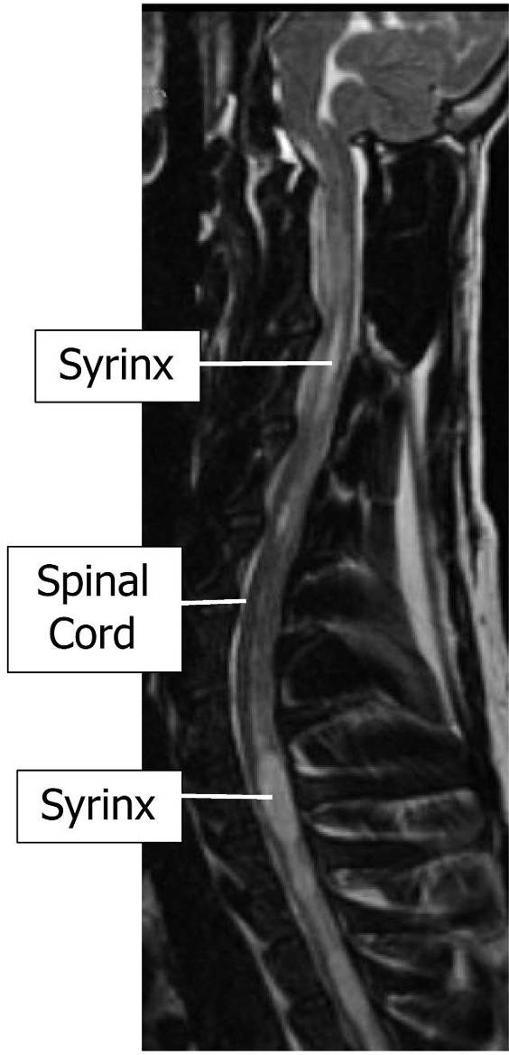
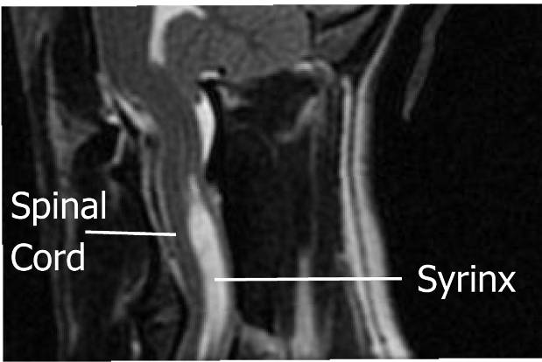
Transverse
Simplified Anatomy and Function of the Spinal Cord
Grey and White Matter
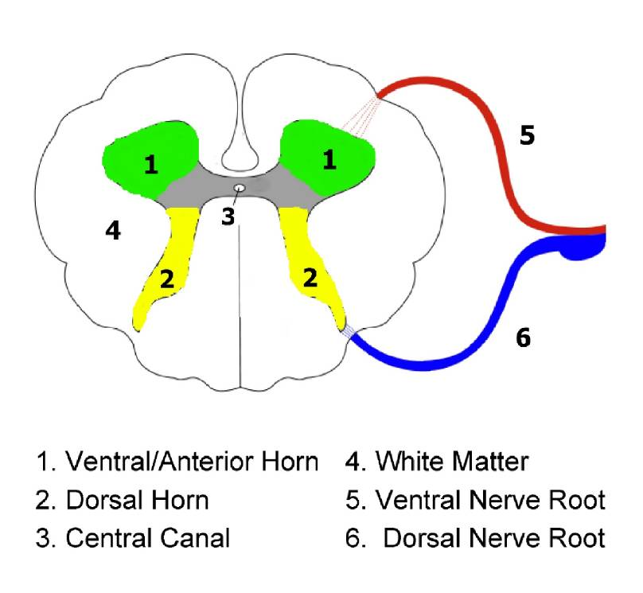
Ventral (abdomen/throat)
Ventral (abdomen/throat)
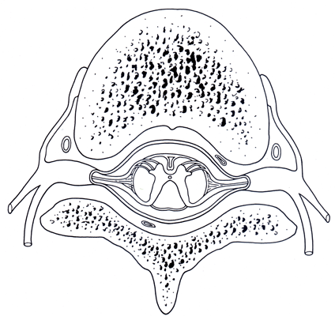
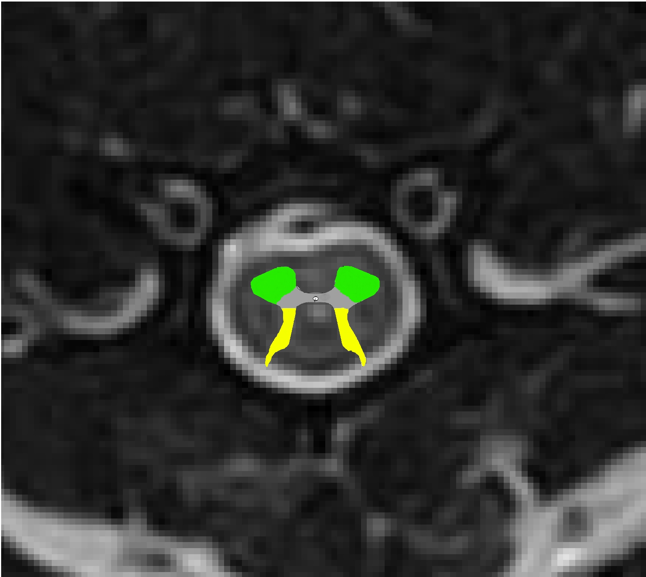
Dorsal (back)
Dorsal (back)

The spinal cord is made up of grey and white matter. Using a computer network as an analogy, the grey matter can be thought of as the actual computer, whereas the white matter represents the network cables connecting the computers together.
Transverse cross-section of the spinal cord
“butterfly” in centre is grey matter

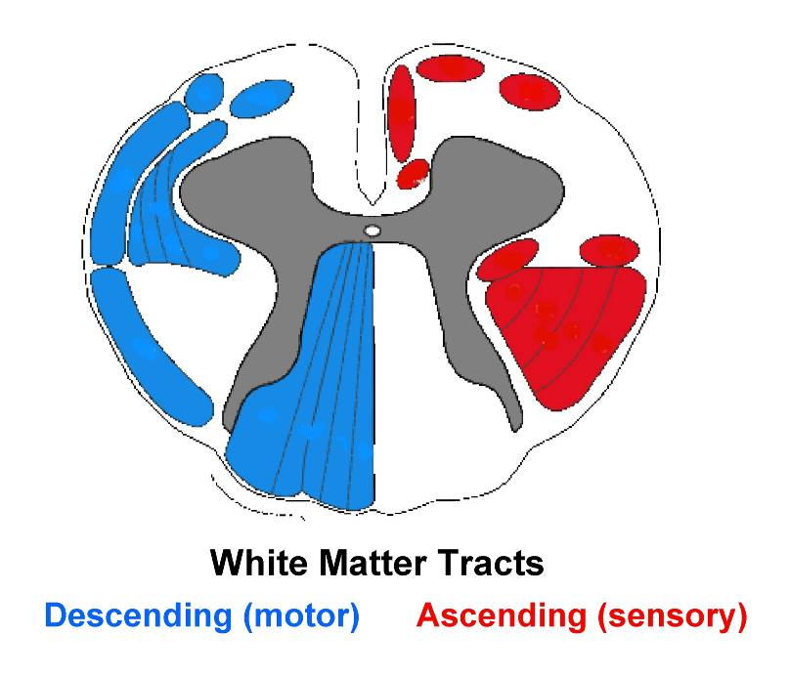
Grey matter - central “butterfly” shaped area of spinal cord containing neurons

White matter - tissue through which messages pass between different areas of grey matter

Spinal Pathways
Ascending (located in dorsal horn)
- sensory information
(e.g. Pain, touch, temperature)

Descending (located in ventral horn)
- motor (movement)
Effects of a Syrinx Simplifed

CLINICAL SIGNS
In a study by Dr. Clare Rusbridge et al , they found that pain is related to syrinx width and symmetry. Dogs with a wider, asymmetrical syrinx are more likely to experience pain, and dogs with a small, narrow syrinx may be asymptomatic.
Ventral Horn Damage - Syrinxes that damage the ventral horn, may result in neurological deficits such as decreased spinal reflexes, muscle atrophy and limb weakness.
Dorsal Horn Damage - Syrinxes that damage the dorsal horn of the grey matter are most likely to cause persistent pain. Dr. Clare Rusbridge also found that the larger the width of the syrinx, the more likely it was that the dog would exhibit pain and scratching behaviour.

Simplified Diagrams of Spinal Cord Cross Section with Syrinx
Ventral Horn of Grey Matter
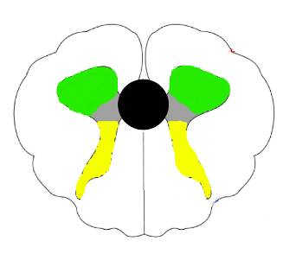
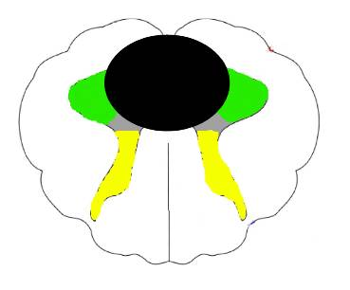
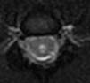
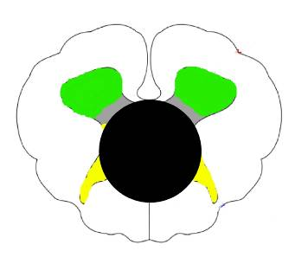
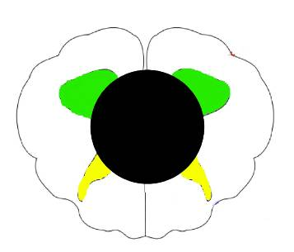
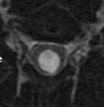
r
Small syrinx not affecting dorsal or ventral horns
Syrinx affecting ventral horn (green) only –> movement affected
Syrinx affecting BOTH dorsal and ventral horns (yellow + green) –> pain + movement affected
Dorsal Horn
of Grey Matter
Syrinx
(black hole)
Syrinx affecting dorsal horn (yellow) only –> pain

Wikepdia
Syringomyelia in cavalier King Charles spaniels: the relationship between syrinx dimensions and pain. C Rusbridge , H Carruthers , M-P Dubé , M Holmes , N D Jeffery. J Small Anim Pract. 2007 Jun 30.
Syringohydromyelia in cavalier King Charles spaniels. C Rusbridge, JE MacSweeny, JV Davies, et al. Journal American Animal Hospital Association. 2000;36:34-41 www.CavalierHealth.org

